**CS601 Assignment # 1 Fall 2021**

**Name**: Abdul Rehman.

**VU ID**: BC200403287.

**Question No. 1:**

The Diagram given below is representing the Manchester encoding scheme. You are required to carefully analyze it and then write the binary pattern represented by the diagram:

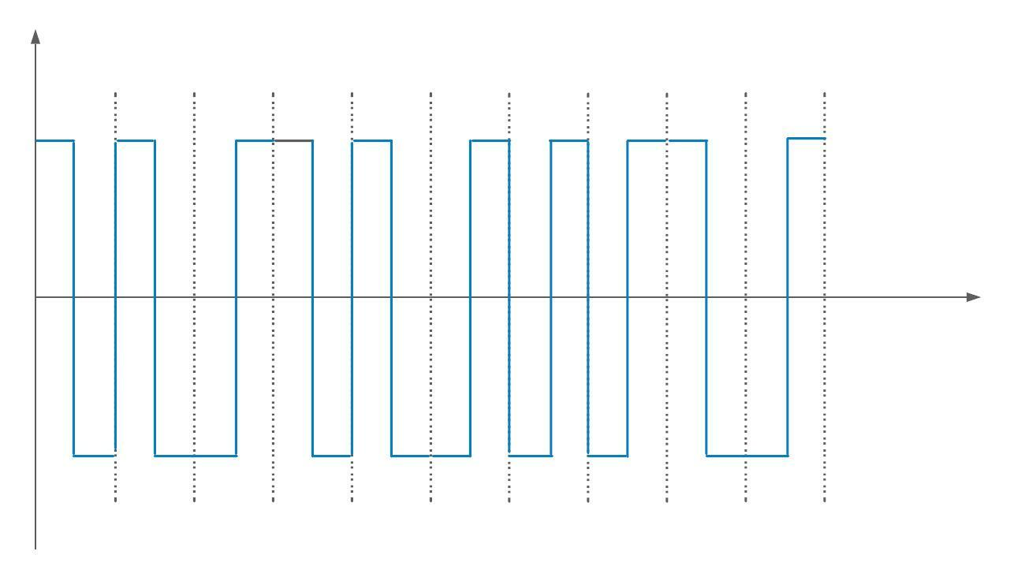

***Hint: First bit is 0 and its voltage level is positive to negative.***

Give your answer in the following table:

**Answer:**

|  |  |  |  |  |  |  |  |  |  |
| --- | --- | --- | --- | --- | --- | --- | --- | --- | --- |
| **0** | **0** | **1** | **0** | **0** | **1** | **1** | **1** | **0** | **1** |

**Question No. 2:**

Suppose we have sampled a low-pass signal with a bandwidth of 350KHz using 2048 levels of quantization.   
  
a. Calculate the Nyquist sampling rate for this signal.

b. Calculate the bit rate of the digitized signal.

**Answer:**

**a. Calculate the Nyquist sampling rate for this signal.**

In low-pass signal, the minimum frequency is 0.

*fmax = 0 + 350 → 11bits per sample.*

*fs = 2 * 350000 → 700000.*

*= 700000 sample per second.*

**b. Calculate the bit rate of the digitized signal.**

The number of bits per sample and the bit rate are:

*nb = log2 2048 → 11bits per sample.*

*N = 700KHz * 11.*

*= 7700KHz.*

*= 7.7Mbps.*